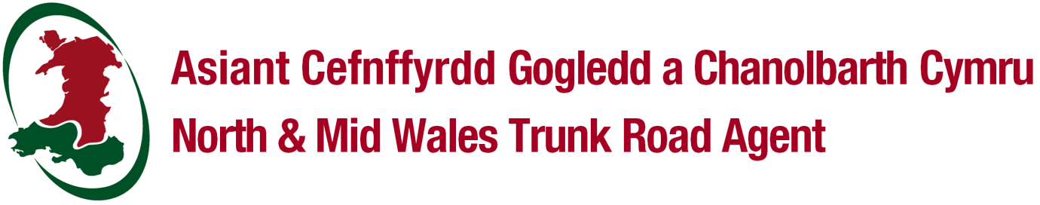
APPLICATION FOR A LICENCE TO ERECT, MAINTAIN AND DISMANTLE SCAFFOLDING, HOARDING AND OTHER STRUCTURES
The Highways Act 1980 – Section 169, 172 a 173

New application
Renewal application

Details to be completed in capital letters and black ink.

NOTE: The maximum licence period will be 3 months. For extended works, NMWTRA will consider, upon application, renewing the licence on a 1 month basis.

Details of applicant

(Mr/Mrs/Miss/other)
Full name
On behalf of (company)
Address
Postcode |  | E-mail
Telephone no. |  | Fax no.
Mobile tel no. |  | Emergency no.

Proposed location of Scaffolding / Hoarding or Other Structures

House name/no.
Street name
Town/village
Postcode
Date from |  | Date to
Brief description of works

Details of Scaffolding / Hoarding or Other Structures | Description:  Length and Width:  Height of Scaffolding:  Length and Width of Footway:  Details of Traffic Management used for erection and dismantling:

Insurance Indemnity Certificate
The licensee shall indemnify North and Mid Wales Trunk Road Agency and Welsh Government to the value of £10 million through Public Liability Insurance against any liability, loss or damage claim or proceeding whatsoever arising out of statute or common law, in respect of the placing and maintaining scaffold, hoarding or other structures on the highway and their removal there from.

Insurance company
Policy number

Fees
The relevant application fee must be paid before consideration is given to your application. Please enclose a cheque (payable to Gwynedd Council) with your application form(s) or phone 01286 685170 / 01286 685169 to pay by card.
*Please note this is non-refundable.

- New application: £68 (Scaffolding for initial 3 months)
- Renewal application: £68 (Scaffolding per month after the initial 3 months)
- New application: £70 (Hoarding or Other Structures for initial 3 months)
- Renewal application:£70 (Hoarding or Other Structures per month after initial 3 months)

Declaration
I/we have received a copy of North and Mid Wales Trunk Road Agency standard conditions for the erection of scaffold/hoarding on the
highway and hereby confirm my/our undertaking to observe and abide by the conditions contained within that document, as well as other additional conditions which may be listed as part of the licence including payment of the associated fees.

Signature |  | Date

General Data Protection Regulation (GDPR): Data is processed in accordance with General Data Protection Regulation 2018. (See privacy notice below).

Return to North and Mid Wales Trunk Road Agent
Unit 5 Llys Britannia, Parc Menai, Bangor, LL57 4BN
01286 685169 / 01286 685170: E-mail: licences@nmwtra.org.uk:

GDPR Privacy Notice
Your personal information
The North & Mid Wales Trunk Road Agent (NMWTRA) operate as Agent on behalf of the Welsh Government (WG) for the trunk road network in North & Mid Wales.
As agent, NMWTRA will assume the role of “Data Processor” on behalf of WG who are the “Data Controller”. WG as Data Controller will be responsible for your personal information.
Why we need your information
The WG will use your information as followed:-
Data Collected | Why we need your information?
Streetworks Application | To process your streetworks applications we shall record personal data.

Justification for using your Information
The WG collects and uses your personal information because it has a legal duty or right to do so; or to perform a public interest task; or because you have given your consent. The legal term for this is called the legal basis of processing.
In this instance, the WG is using your personal information because it is undertaking a task in the public interest.
The WG will not use your information for automated decision making or profiling.
How your data will be Shared & How long will the data be retained
Your data may be shared with the following organisations and the data will be retained as detailed below.
The WG will not transfer your personal information to another country.
Data Collected | Who we will share your data with? | Retention Period
Streetworks Application | - Trunk Road Agents | 15 years

Your rights
You have legal rights, and it is important that you know what they are.
You have the right to obtain a copy of your personal data. You will be provided with copies of your personal data within the statutory period of one month (or if providing your personal data is a complex matter, this will be done as soon as is reasonable within 3 months). Your personal data will be provided to you free of charge, however, if your request is deemed manifestly unfounded or excessive, a reasonable fee will be charged. You ask to obtain your personal data by contacting the
WG Data Protection Officer.
You have the right to have information about you corrected.

You have the right to ask that your personal data is rectified if it is incorrect or incomplete. This will be done within 1 month, or if your request is complex, within 3 months.

The right to have personal data erased in specific circumstances:

- Where the personal data is no longer necessary in relation to the purpose for which it was originally collected/processed;
- If you withdraw your consent;
- When you object to the WG processing and there is no overriding legitimate interest for continuing the processing;
- If the personal data was unlawfully processed;
- When the personal data has to be erased in order to comply with a legal obligation; or
- When the personal data is processed in relation to the offer of information society services to a child, e.g. an app developed specifically for children.

The right to restrict processing. Where it is claimed that data is inaccurate or the right to erasure has been exercised you can require the WG to restrict processing until verification checks have been completed.
The right to data portability. Under certain circumstances, you have the right to obtain and reuse your personal data across different circumstances.
The right to object. In addition to the right to object to your information being used for direct marketing, you have the right to object to processing based on the performance of a task in the public interest/exercise of official authority (including profiling), and processing for purposes of scientific/historical research and statistics.
The right to withdraw your consent at any time if consent has been relied upon originally.
Rights in relation to automated decision making. You have the right not to be subject to decisions based solely on automated processing, including profiling, which produces legal effects on you or affects you in a significant way.
Data Protection Officer: The email address for the WG Data Protection Officer is DataProtectionOfficer@gov.wales
If you wish to complain about the way that the WG has used your personal data contact the Data Protection Officer.

If you are not satisfied with their response you also have the right to contact the Information Commissioner:

https://ico.org.uk/concerns.

Information Commissioner’s Office
Wycliffe House
Water Lane
Wilmslow
Cheshire
SK9 5AF
Telephone: 01625 545 745 or 0303 123 111

